“War and Peace”: History, Fiction and “the Russian Soul”
Forms 10-11
On-line Learning


Панорамная экскурсия по музею: https://yandex.ru/video/preview/5886492908147783201?from_type=vast&parent-reqid=1760124990149945-16807818578068945391-balancer-l7leveler-kubr-yp-klg-182-BAL&text=музей+толстой+война+и+мир+в+москве+вднх+панорамная+экскурсия

Рабочий лист для дистанционной работы содержит задания, которые возможно выполнить, используя панорамную экскурсию по музею, а также фотоматериалы (см. Приложение). Предлагаемые материалы можно полностью или частично.

Hall 1. The Central Hall

Task 1. Warm-up
What do you know about the Russian literature of the 19th century, the great authors of the time? What is “War and Peace” about? Use the vocabulary to answer the questions: biography, novelist, philosopher, moralist, pacifist, aristocratic family, landowner, serf, serfdom, realism, epic novel, historical context, the Napoleonic Wars, the Battle of Borodino, patriotism, courage, fate, destiny, search for meaning, aristocracy, gentry, peasant, uniform, weapon, manuscript, portrait, artifact, exhibit, curator.
____________________________________________________________________________________________________________________________________________________________________________________________________________________________________________________________________________________________________________________________________________________________________________________________________________________________________________________________________________________________

Task 2. Warm-up
Work in groups. Look at the sculpture of Leo Tolstoy and study the holographic image in the farther part of the hall. Use the information to the exhibits in the hall to do the task. Explain the meanings of the adjectives wise, serious, thoughtful, determined, kind, stern. Use them to give descriptions.
Group 1 researches for 3-5 key biographical facts about Leo Tolstoy.
Group 2 researches for the historical background of the Napoleonic Wars (main events, Napoleon, Kutuzov).
Group 3: finds out about the main characters of “War and Peace”, their personalities and roles.
What episodes from “War and Peace” are represented in the holographic exposition? Put the episodes in the order they follow in the novel.
________________________________________________________________________________________________________________________________________________________________________________________________________________________________________________________________________________________________________________________________________________________________________________________________________________________________________________________________________________________________________________________________________________________________

Write down more adjectives to describe the characters of “War and Peace”.
________________________________________________________________________________________________________________________________________________________________________________________________________________________________________________________________________________

Task 3. Reading/Discussion
Read the statements, mark them fact (F) or opinion (O), explain why.
Leo Tolstoy came from an aristocratic family but dedicated much of his life to helping ordinary people and questioning social norms.

Fact or opinion?
Statement | Explanation
Tolstoy was a wealthy landowner.

He believed in living a simple life.

He was a pacifist.

His ideas are still relevant today.

Hall 2. Peace, Hall 3. War

Leo Tolstoy spent years researching this period, reading memoirs, visiting battlefields. He wanted to show not just the “big history” but also the human experience of war, “the Russian soul”. Learn the information on historic context (look at maps, military uniforms, weapons).

Task 4. Speaking
Answer the questions: What was the significance of the Battle of Borodino? Who were the key military leaders involved on both sides? List 3 key historic events or figures from this period shown in the exhibits.
________________________________________________________________________________________________________________________________________________________________________________________________________________________________________________________________________________

What feelings and emotions do these exhibits (uniforms, weapons) evoke in you? How do you think ordinary people felt during these wars? (Vocabulary reminder: fear, courage, patriotism, suffering, hope, despair)

Task 5. Character Match & Description (Reading/Discussion)
Here you can see illustrations from ’War and Peace’, descriptions of its main characters, and objects that recreate the aristocratic life of the time. These are the worlds of the Rostovs, the Bolkonskys, and the Bezukhovs.
Find short descriptions of Pierre, Natasha, and Andrei among the exhibits. Which character do you find most interesting and why? How do their personal journeys reflect the themes of the novel (love, search for meaning, destiny)?
Choose one character from “War and Peace” and describe their personality in 2-3 sentences.
____________________________________________________________________________________________________________________________________________________________________________________________________________________________________________________________________________________________________________________________________________________

Task 6. Quote Analysis (Group work/Discussion)
Leo Tolstoy explored many profound themes: the nature of war and peace, the search for truth, the role of the individual in history, love, family, and faith.
Comment on the quotes. Answer the questions:
- What does the quote mean to you?
- How does it relate to Tolstoy's ideas and the novel's themes?

Example Quotes:
- “There is no greatness where there is no simplicity, goodness, and truth”.
(L. Tolstoy)
- “If everyone fought only for his own convictions, there would be no war”. (Andrei Bolkonsky)
- “Life is everything. Life is God. Everything changes and moves and that movement is God. And while there is life, there is joy in the consciousness of the divine”. (Pierre Bezukhov)

Task 7. Consolidation & Reflection
Answer the questions:
What was the most surprising or interesting thing you learned today about Tolstoy, “War and Peace”, or the historic period?
How has this museum visit changed or deepened your understanding of Russian literature, history and “the Russian soul”?
If Leo Tolstoy were alive today, what do you think he would say about our modern world, about current conflicts, or about people’s search for happiness?
Write down one new word or phrase you learned today and explain its meaning.
________________________________________________________________________________________________________________________________________________________________________________________________________________________________________________________________________________

Приложение

В павильоне 61 на ВДНХ открылась мультимедийная экспозиция «Лев Толстой. Война и мир. Ожившие страницы»

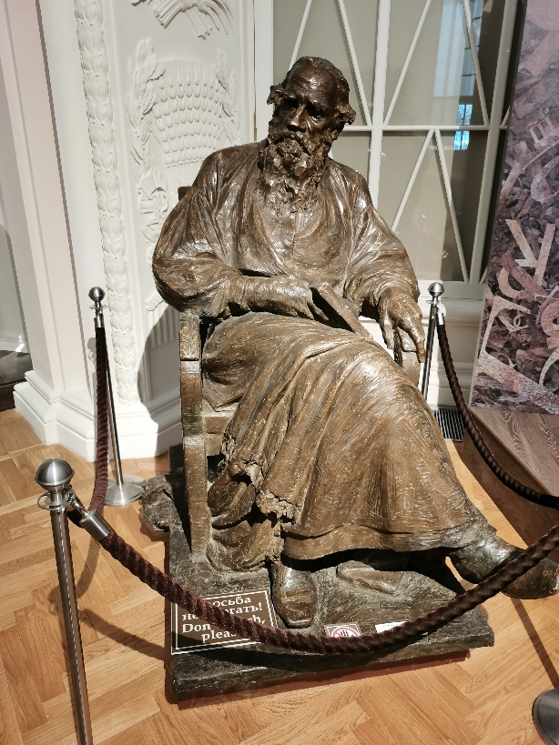

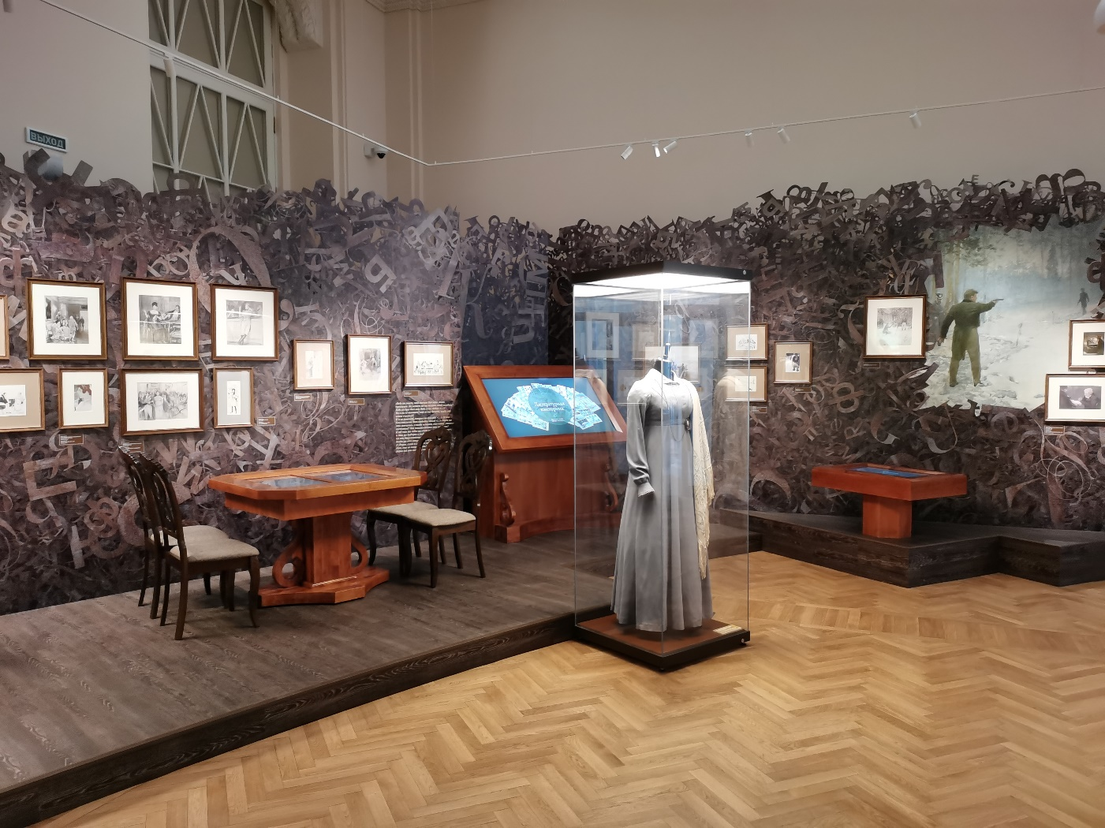
Расположение трёх залов выставки отражает общую идею экспозиции: с одной стороны «Война», с другой – «Мир», между ними – центральный зал, здесь посетители знакомятся с философскими взглядами писателя.
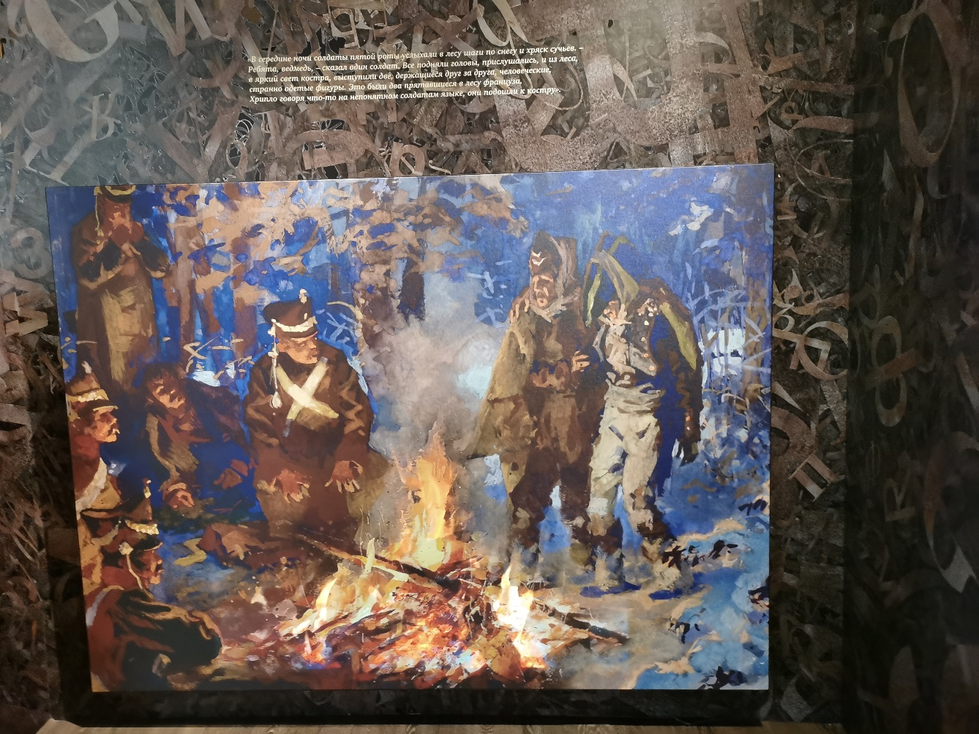

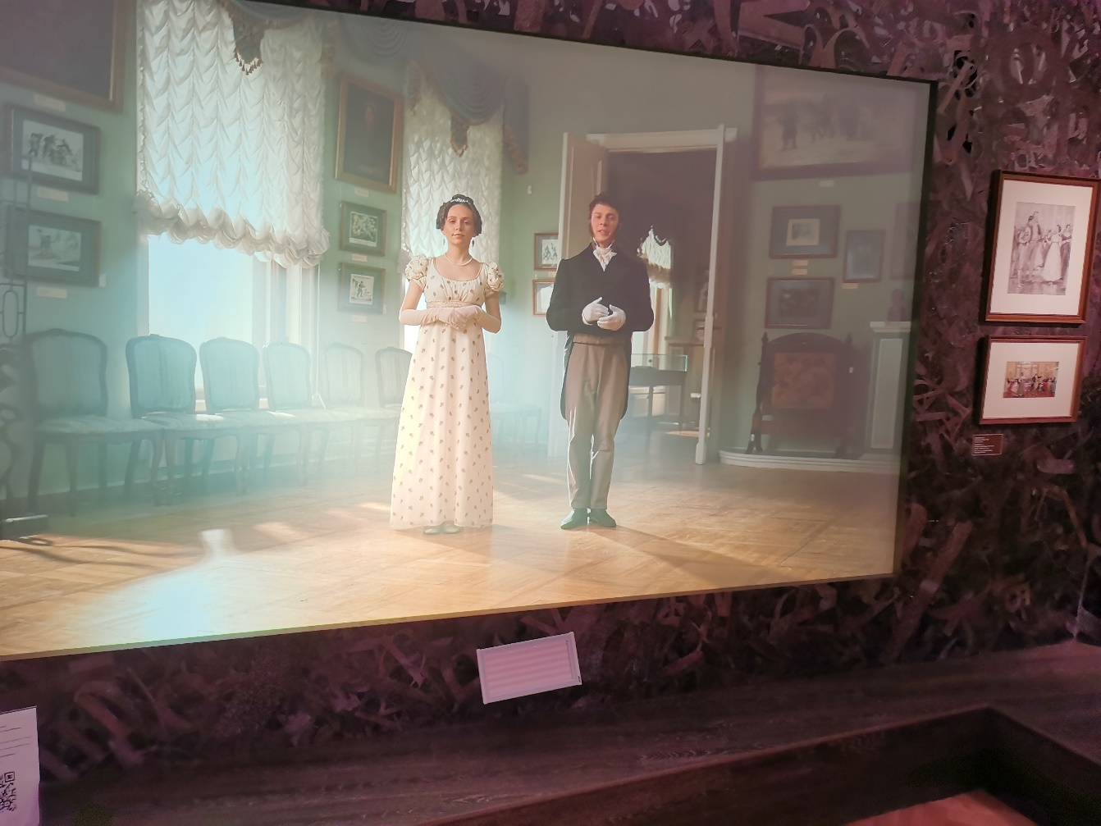
Здесь интересно поиграть в старинные карточные игры: на одном интерактивном столе обучающая программа, на другом можно начать игру.
На интерактивных дисплеях посетители знакомятся с дуэльным кодексом,
с историей масонства.
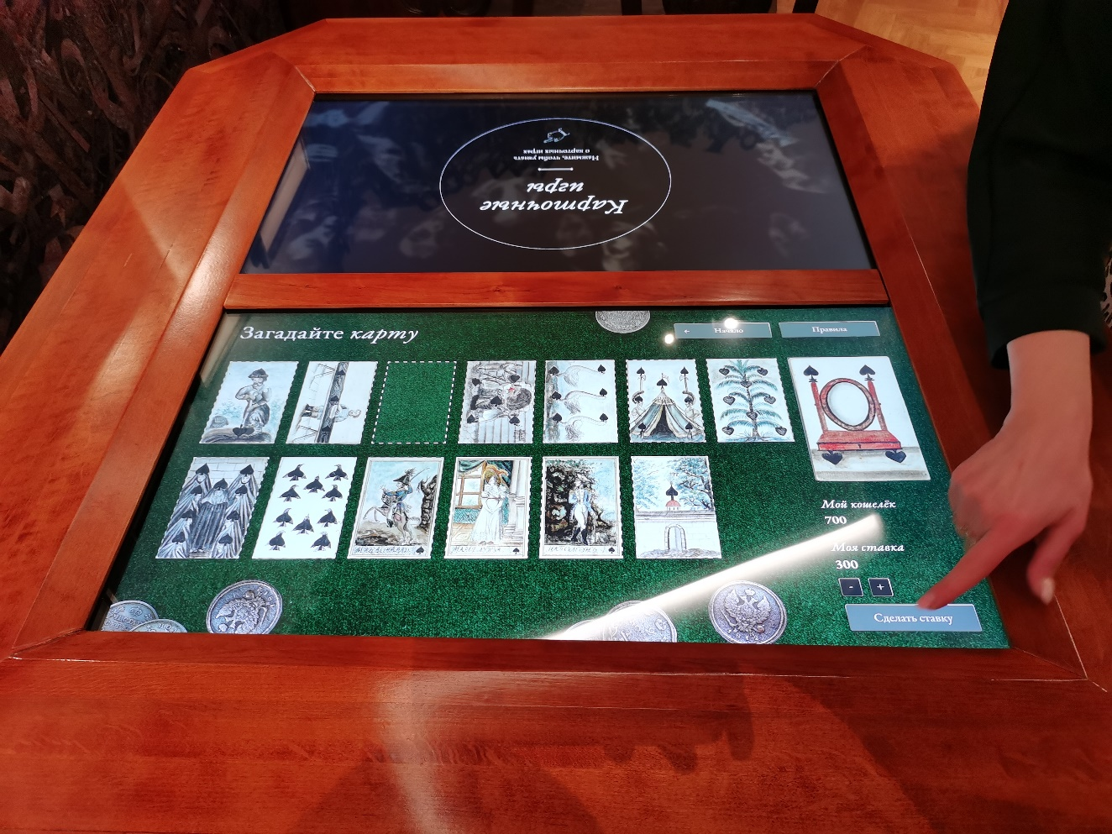

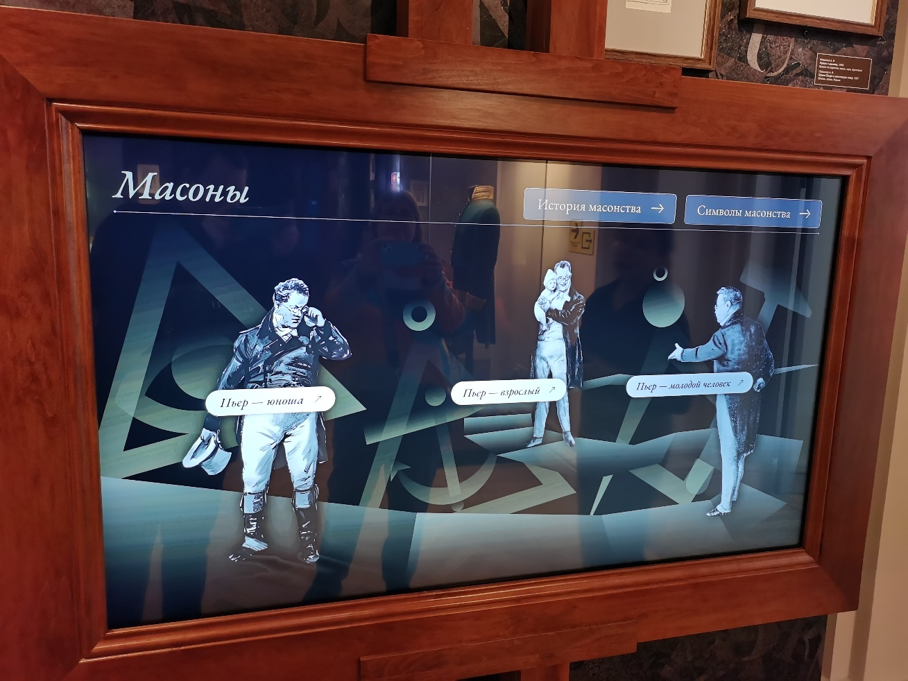
В зале “Война” гости выставки могут наблюдать за ходом Бородинского сражения. В зале установлены интерактивные дисплеи с тематическими викторинами.
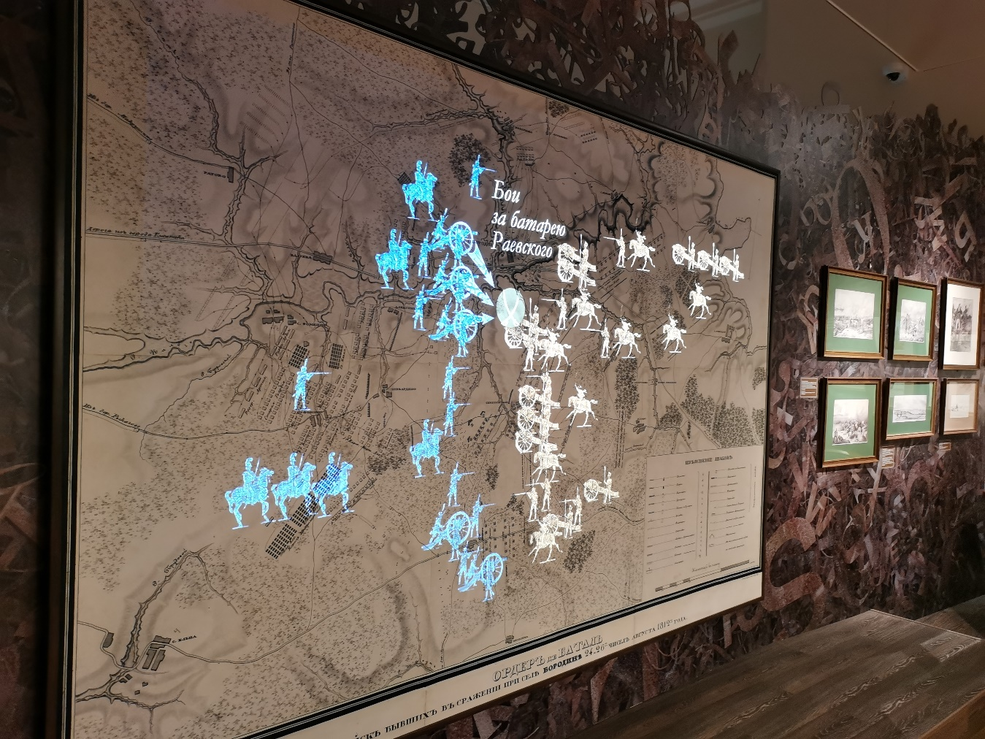

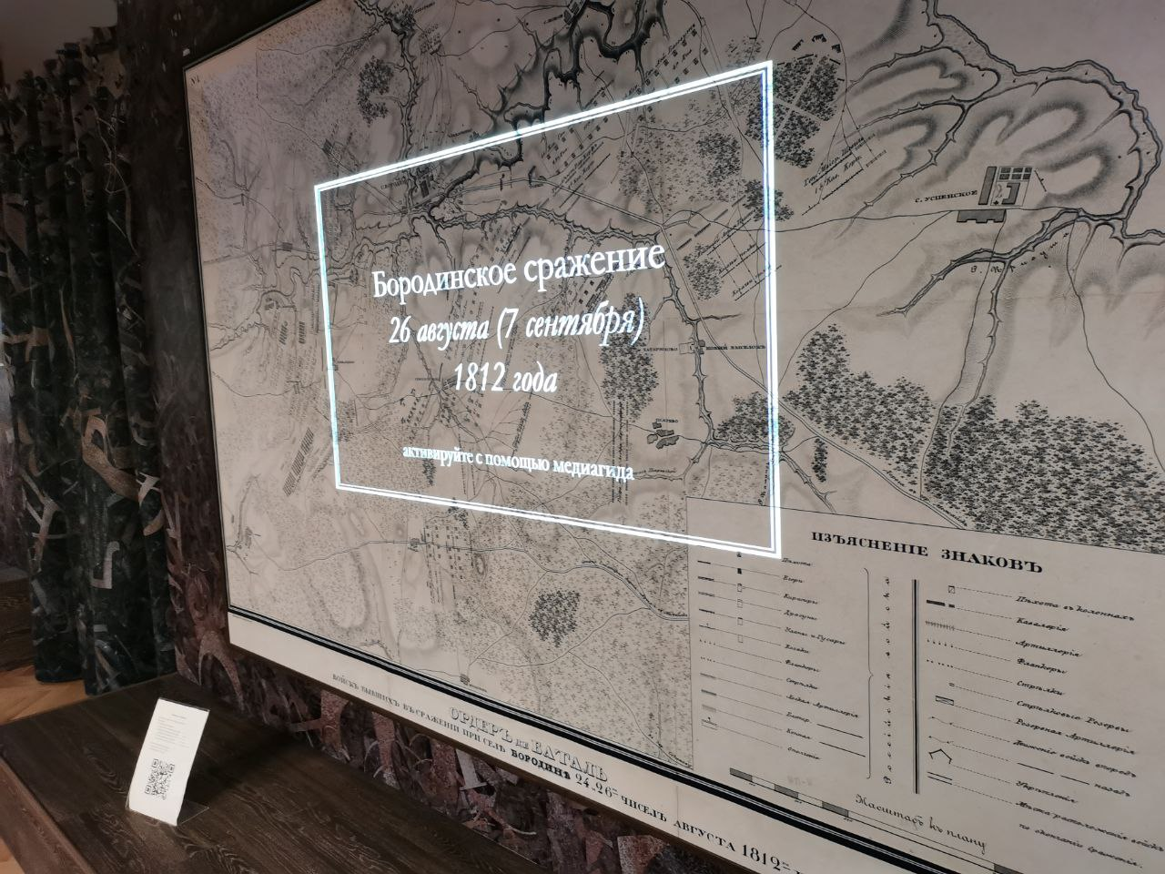
В центральном зале установлена трёхметровая проекционная сфера – шар – как символ мировой гармонии в понимании Льва Толстого. Демонстрируется графический видеоролик – фантазия на тему сна Пьера Безухова и образов персонажей романа. Под сферой размещены витрины и информационные дисплеи.
